**Living Document:**

**Project Aim:**

To create a service robot platform which could be used to aid with staffing shortages in retail stores in New Zealand.

**Team Scope:**

To design and develop a service robot platform. The scope of the project will be limited to an indoor robot, designed to traverse single level structures. It will be operational around a co-active environment that includes humans, guide dogs and the robot itself.

**Objective:**

We will accomplish our scope by creating a moving chassis system that is able to support mechanical, electrical, software and customer interaction portions of a robot. This will consist of a full break down of; the hardware and mechanical design in both the CAD and BOM format, the IOT system used, costings, environmental and social effects, relations to the Washington Accord and our methodology for the design and decision making.

**Demand for this product:**

* New Zealand unemployment rates are very low.

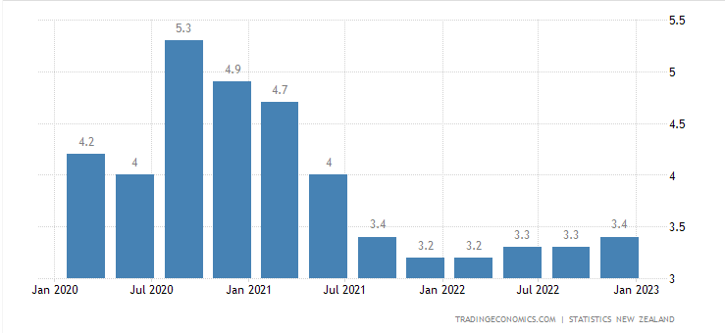

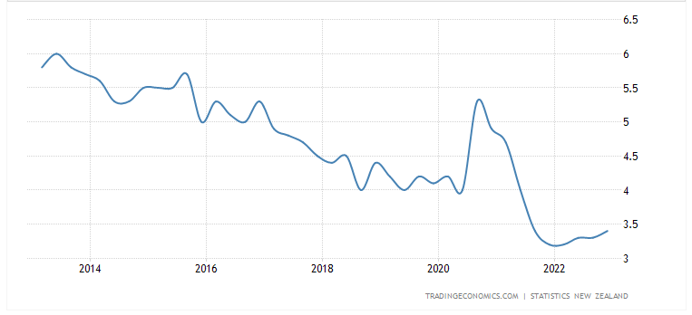

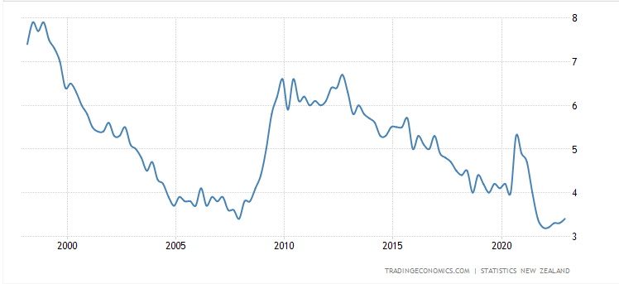

* Increased cost of living means a large pool of young people are moving out of New Zealand.

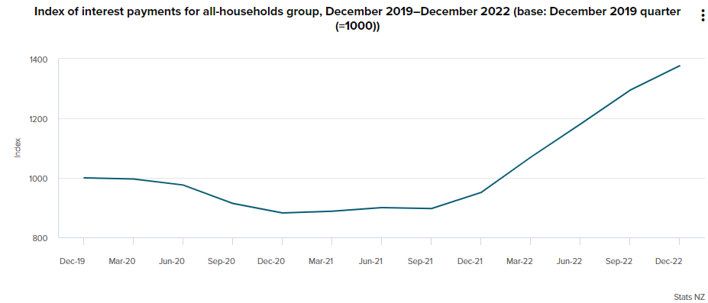

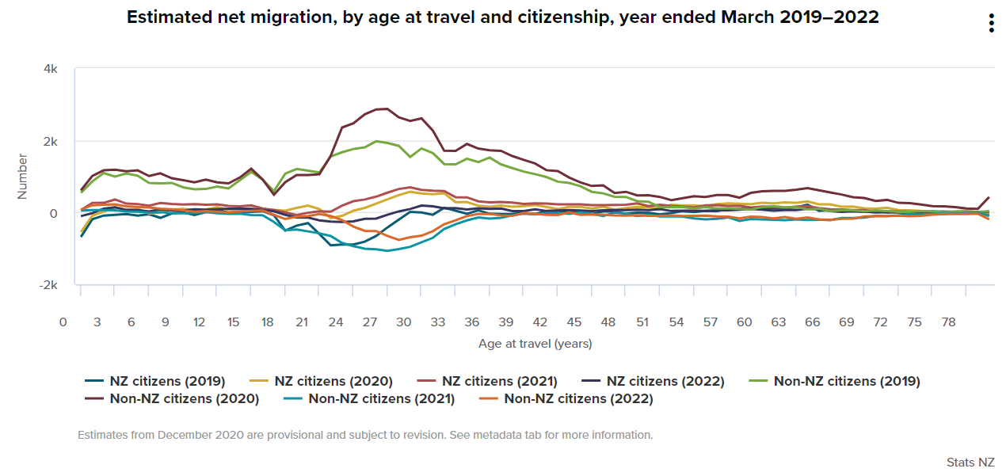

* Staff shortages reported all around the country.

**Proof this product will work:**

* Robotic waiters being implemented around New Zealand (Queenstown is a good example) to take workload off existing staff. - Positive review.
* Robotic hotel staff have been implemented by the Millenium.
* Grobotics - Brand
* Lowes Robot
* International service robot market size estimated to be US$26.09 billion in 2023.
* International commercial service robot market size estimated to be US$16.15 billion in 2023.
* International growth rate estimated to be 5.85% between 2023 - 2027 resulting in market volume of US$32.75 billion in 2027. (CAGR)
* New Zealand service robot market size estimated to be US$41.00 million in 2023.
* New Zealand commercial service robot market size estimated to be US$21.17 million in 2023.
* New Zealand growth rate estimated to be 2.62% between 2023 - 2027 resulting in market volume of US$45.47 million in 2027. (CAGR)

**Role Breakdown:**

This project will be divided into four major parts, all of which will coincide with each other:

Mechanical Design

The mechanical design of the robot will involve designing the frame of the robot, the drive system, and the structural components for all other systems. The robot should be compact, lightweight, and durable. It should be able to move smoothly through the store and navigate around obstacles.

Electrical Design

The electrical design will include the power supply and management system, sensors, and embedded systems. The power supply should be reliable and provide sufficient power for the robot to operate continuously for extended periods. The sensors should enable the robot to interact with customers and navigate the store. The embedded system should be able to integrate all these components and enable the robot to perform its tasks autonomously. The electrical design will also include emergency failsafes.

Software Development

The software development will involve developing the algorithms and software to control the robot's behavior. This will include developing the navigation, environment recognition, and item location systems. The software should be able to recognise and adapt to new environments and situations. It should also be able to handle errors and failures gracefully.

Management Part

The management part will involve the planning, coordination, and execution of the project. This will include setting project milestones, assigning tasks to team members, monitoring progress, and ensuring that the project is completed on time and within budget. It will also involve ensuring that the project meets the requirements of stakeholders and ensuring that the robot is safe and complies with relevant regulations.

**Deliverables**

**Mechanical Design - Hannah Larsen:**

a. CAD models and drawings of the robot body and driving system.

b. CAD models and drawings of the mounting mechanisms for all other systems.

c. Bill of materials for the mechanical components.

d. Physical build of robot body, drive system and other system mounts.

**Electrical Design - Inuka panditha:**

a. Schematic diagrams of the electrical system.

b. Bill of materials for the electrical components.

c. Hardware for controlling the electrical components.

d. Physical working of electronic systems.

**Software Development - Joe Chance:**

a. Source code for the navigation system, IoT system, environment recognition system, and item location portfolio.

b. Software for controlling the robot's behavior.

c. Documentation of the software development process. - Github repository

d. User experience, user interface. (UEUI)

**Management Part - Rebecca Aitken:**

a. Project plan and schedule.

b. Progress reports and status updates.

c. Risk management plan.

d. Quality assurance plan.

e. External design and consumer interaction.

**Constraints:**

1. The robot should be safe to operate in a retail environment and comply with relevant regulations.
2. The project should be completed within the allocated budget and timeline.
3. The robot should be able to operate autonomously and handle errors and failures gracefully.
4. The robot should be capable of performing the required tasks to assist customers and work homogeneously with stakeholders.
5. The robot should be designed with ease of access and maintainability in mind.

**Assumptions:**

1. The project team has the necessary skills and expertise to design and build the robot.
2. The project team has access to the necessary equipment and materials to build the robot.
3. The project team has adequate space for testing the prototype.

**Washington Accord:**

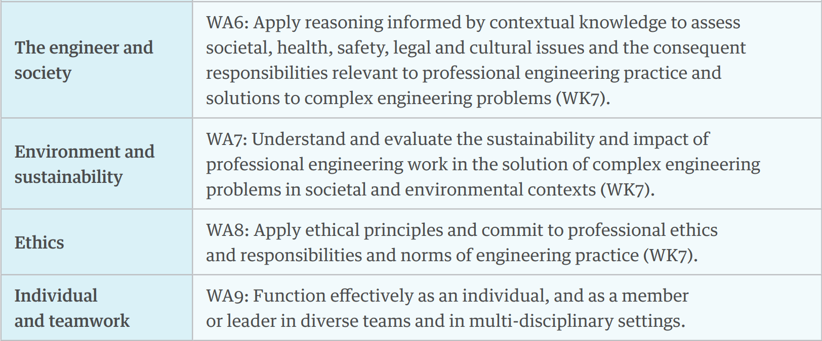

* **Relate project to.. 4 slides**

How we will address these:

* Develop testing plans for safe operations around a range of age groups and physical limitations including guide dogs.
* Comply with all relevant New Zealand laws.
* Ensure the design is culturally appropriate and does not discriminate in any capacity.
* Comply with a range of New Zealand environmental certifications.
* Act in a socially, environmentally and ethically appropriate manner at all times and incorporate these values into the design.

**Stakeholder Breakdown:**

| **Stakeholder** | **Opportunities** | **Risks** |
| --- | --- | --- |
| Diane | * Display Students capabilities. * Help during events. | * Poor representation if it doesn’t work. |
| Existing Employees of retail companies | * Able to better focus on other, potentially more rewarding tasks. * Reduction of stress due to understaffing. * Create more time for uptraining of other, potentially more important skills. * Improved pay capacity due to fewer staff requirements. | * Need new training to co-exist with the robots. * Awareness of shared technology/human space. - Health and Saftey. * Reduced opportunity to develop customer interaction skills. |
| Retail Companies | * Remove some of the pressures of understaffing. * Reduced wage expenses. * More efficient - removes human error. * Guaranteed level of service - robots do not tire or anger. | * Initial expenses of service robot. - Training + implementation. * Need to be more precise with stocktaking system. * Inability to adjust beyond programming to new situations. - Can’t recognise anger/ anxiety in customers. * Planning for maintenance + charging + upgrating required. |
| Customers of retail companies | * Easier and faster to find stock. * Language barrier removal. * Some will feel more comfortable asking for help from an impartial robot. * Service will not vary. - robot does not have variable moods, energy levels etc. | * Distrust of new technology. * Desire for human interaction. * Annoyed with limited functions. |
| Design team (Capstone group) | * Learn/practise new skills. * Further qualification. * Satisfaction * Connections * Experience/employability * Teamwork experience | * Pressure/stress to meet budget and timeline. * Learning on the go under pressure / risk of failure due to lack of knowledge. * Team issues. * Physical harm in workshop. |
| Investors | * Returns * Connections * Exposure | * Product failing and not making returns/making a loss. |
| Competitiors | * Can enhance own products based on this product. * Proof the service robot will work in the industry - Case study. | * Reduced market share. * Forced to make improvements to retain competitiveness. |
| Massey University | * Reflects student skill level - quality of teaching. * Further development of project. * Can be used in open days etc. * Intellectual property. | * Poor representation. * Loss of investment |
| Supervisor - Dr. Fraser Noble | * Platform for research - saves time. * Allow focus on value adding proposition / further development. * Project opportunities | * Loss of parts. |
| Robot Manufacturers/Suppliers | * New business - increased profits. |  |
| Economy | * New work opportunities for maintenance and production of service robots. |  |
| Government Body |  | * May require new regulations to be developed. |

**Design Specifications:**

|  | **Specification:** | **Description:** | **Requirement:** |
| --- | --- | --- | --- |
| 1. | Noise | Will not irritate customers or staff. | >70 dB |
| 2. | Size | Will be able to pass people/trollys/other robots in an isle. | > 920mm x 575mm x 2000mm |
|  | Weight |  |  |
| 3. | Mobility | Will be able to move through the entirety of a single level store. |  |
| 6. | Customizability | Will be customisable to the company purchasing it. | Customisable external shell  Coulour + Logo |
| 7. | Safety | Will abide by all New Zelaand Regulations.  Will not pose a risk to customers or staff. | ISO 10218 - 1:2011  Worksafes - ‘Safe Use of Machinery’ best practices. |
| 8. | Maintenance | Will be easy to conduct regular maintenance.  Modular Design | All components will be easily accessible with only standard tools being required. |
| 9. | Durability | Warrenty | All components are designed to last at least 5 years. |
| 10. | Environmentally Sustainable | Will abide by all New Zealand Regulations. | Environment Act 1986  Resource Managment Act 1991  Transport Act 1962  RoHS Directive  WEEE |
| 11. | Cost Efficient | Will cost less to run and maintain than the human equivalents wages. | > $35,000 NZD |
| 12. | Remotely Accessible |  |  |
| 13. | Integration with Existing Systems |  |  |
| 14. | Battery Life |  |  |
| 16. | Prototype within Budget. | Will be prototyped within the budget provided by the University. | >$1000.00 to prototype. |
| 17. | Regulations | Will abide by all New Zealand regulations. |  |
| 18. |  |  |  |

**Risk Evaluation and Mitigation**

* Work is within Scope and realistic + Scope gets re-evaluted and can change and the gnatt chart can change with it.
* Injury
* Money
* Supply/demand

**What we had vs What we have done**

**References:**

*25 Years Washington Accord*. (2014). International Engineering Alliance. https://www.ieagreements.org/assets/Uploads/Documents/History/25YearsWashingtonAccord-A5booklet-FINAL.pdf

*Annual net migration loss of 7,300 | Stats NZ*. (2022, May 12). Www.stats.govt.nz. https://www.stats.govt.nz/news/annual-net-migration-loss-of-7300/#:~:text=Young%20adults%20drive%20net%20migration

*Living costs increase for all household groups | Stats NZ*. (2023, February 2). Www.stats.govt.nz. https://www.stats.govt.nz/news/living-costs-increase-for-all-household-groups/

McClure, T. (2022, May 18). More people leaving New Zealand than entering as young flee high cost of living. *The Guardian*. https://www.theguardian.com/world/2022/may/18/more-people-leaving-new-zealand-than-entering-as-young-flee-high-cost-of-living#:~:text=Young%20New%20Zealanders%20are%20leaving

*New Zealand Unemployment Rate - 2022 Data - 2023 Forecast - 1985-2021 Historical*. (2023). Tradingeconomics.com. https://tradingeconomics.com/new-zealand/unemployment-rate#:~:text=Unemployment%20Rate%20in%20New%20Zealand%20averaged%205.82%20percent%20from%201985